**Quck Entries**

1) Click Menu: Test -> Quick Media (or Click F3), we create one sample Media record

2) Click Menu: Insert (Alt+I) to insert this new Media into system

3) Or Click Menu: Save (Alt+a) to update this new Media to current selected Media

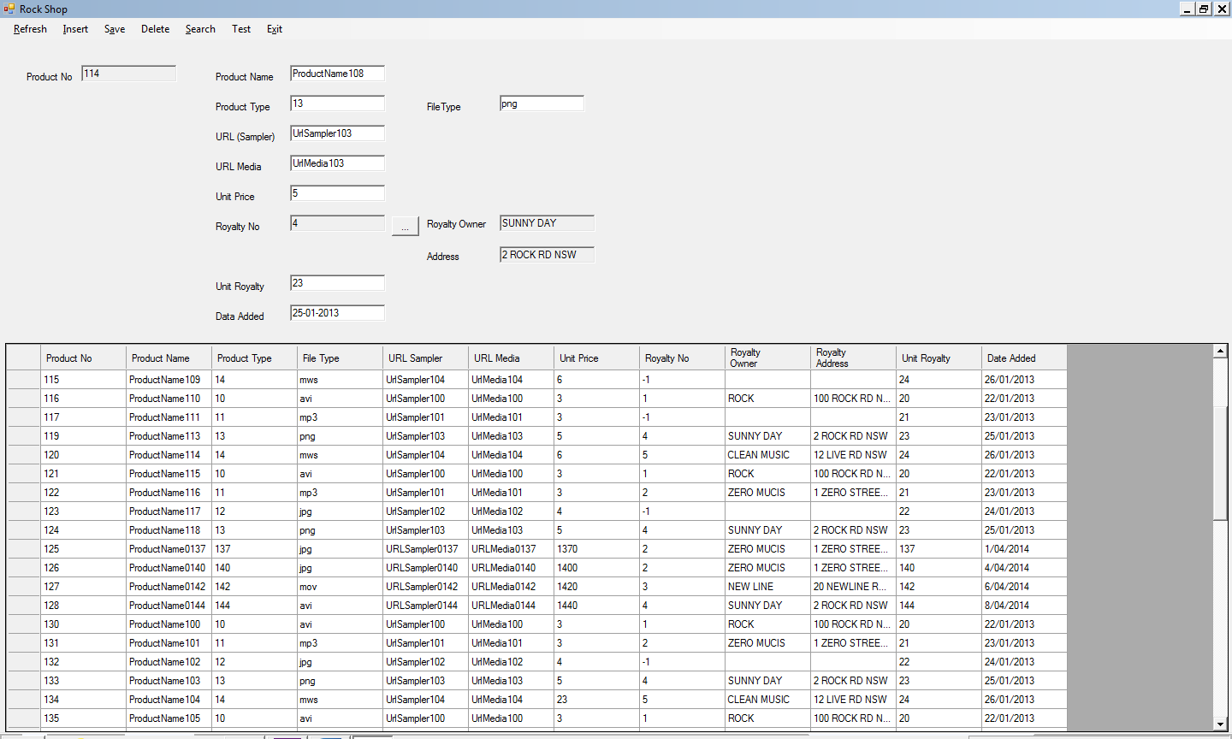

**Test Data Extracted from an Excel Sheet**

1) Click Menu: Excel Data – Medias

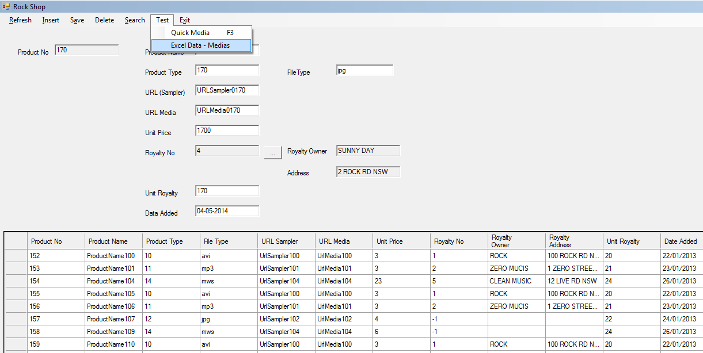

2) Select “TestData_Medias.xlsx” (when in Excel 2009 or before, select “TestData_Media.xls”)

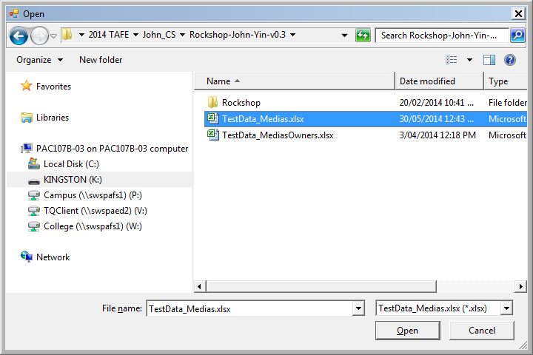

3) Test script create log file

Each time of test result will be saved in the same directory as TestData_Medias_yyyy_mm_dd_hhmm.xlsx, such as “TestData_Medias_2014_06_02_0527.xlsx”.

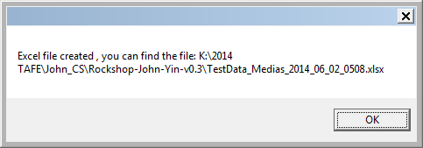

4) Confirm to run test script

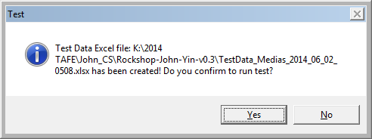

5) Insert new Medias

You could see in our test script files:

* We try to insert 20 new Medias
* But only the legal Medias (9 Medias in our example) can be inserted, and illegal Medias records have null fields or wrong type of field values

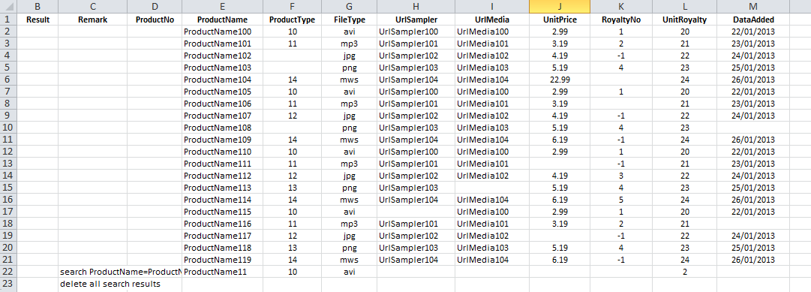

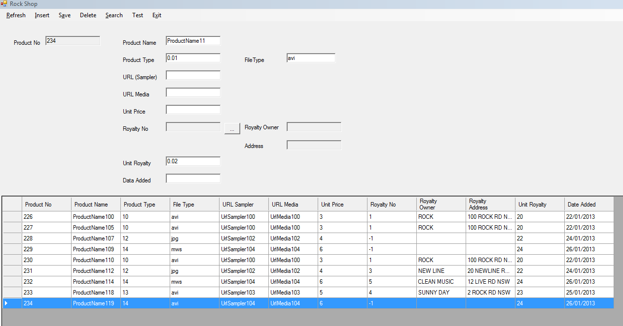

6) Then, we try to find all Medias have following field values and delete them:

* + ProductName=ProductName11%
  + ProductType=1%
  + FileType=avi
  + UnitRoyalty=2%

We can find 3 Medias meet our search conditions, and prompt us before script deletes each of them.

Notes: we use a wildcard “%”, for any zero or more characters in our search conditions

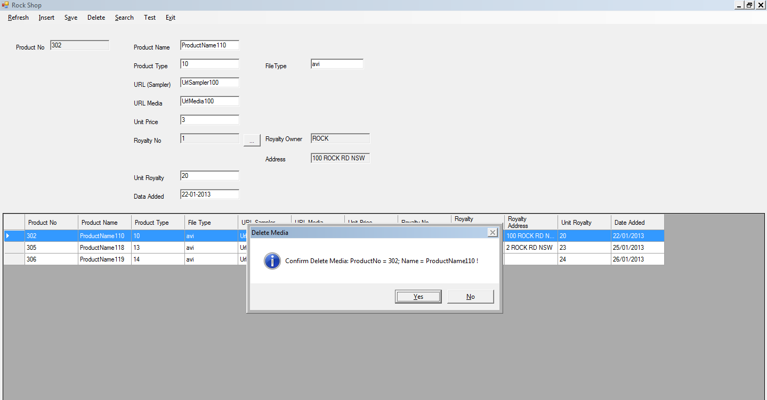

7) At last, we could check our Log file to find all script Actions results

